SQL QUERY
DESKTOP-57HM527\SQLEXPRESS
KPI’s
Checking dataset imported
SELECT *
FROM pizza_sales
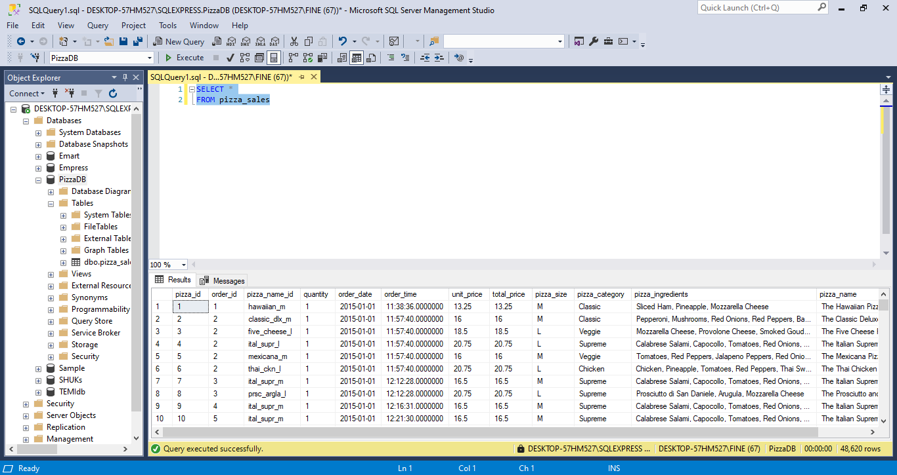
- Total Revenue:
SELECT SUM(total_price)
FROM pizza_sales 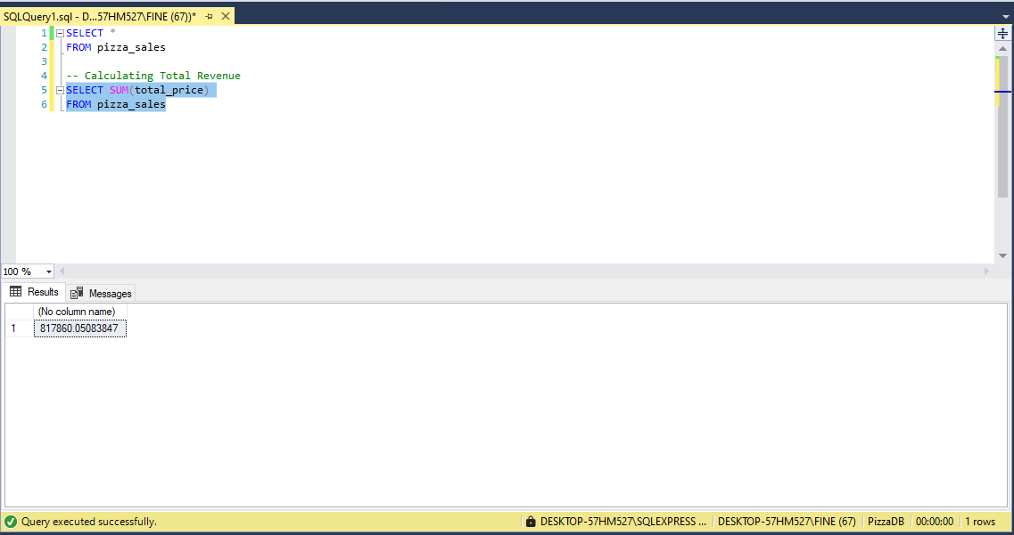
- Average Order Value
SELECT SUM(total_price) / COUNT(DISTINCT order_id)
AS Avg_Order_Value
FROM pizza_sales
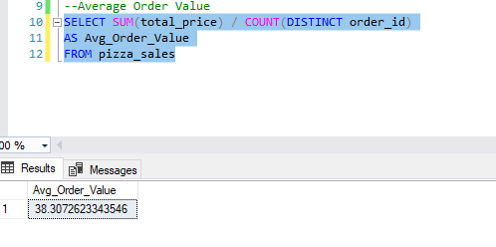
- Total Pizza Sold
SELECT SUM(quantity)
AS Total_PIzza_Sold
FROM pizza_sales
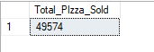
- Total Orders
SELECT COUNT(DISTINCT order_id)
AS Total_Orders
FROM pizza_sales
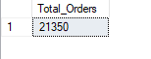
- Average Pizza Per Order
SELECT SUM(quantity) / COUNT(DISTINCT order_id)
AS AVg_Pizza_Per_Order
FROM pizza_sales
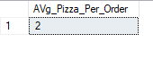
SELECT CAST(CAST(SUM(quantity) AS DECIMAL (10,2)) /
CAST(COUNT(DISTINCT order_id) AS DECIMAL (10,2)) AS DECIMAL (10,2))
AS AVg_Pizza_Per_Order
FROM pizza_sales
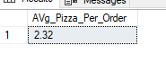
N:B – Add CAST to see in decimal places.
CHARTS:
- Daily trends for total Orders
SELECT DATENAME(DW, order_date) AS order_day, COUNT(DISTINCT order_id) AS Total_orders
FROM pizza_sales
GROUP BY DATENAME(DW, order_date)
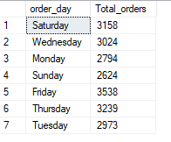
Friday tops the list with (3538) orders
N.B: DW (Date of the week)
- Monthly trends for total orders
SELECT DATENAME(MONTH, order_date) AS order_month, COUNT(DISTINCT order_id) AS Total_orders
FROM pizza_sales
GROUP BY DATENAME(MONTH, order_date)
ORDER BY Total_Orders DESC
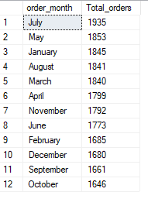
- Percentage of Sale per Pizza Category:
SELECT pizza_category, SUM(total_price) * 100 / (SELECT SUM (total_price) FROM pizza_sales) AS PCT
FROM pizza_sales
GROUP BY pizza_category

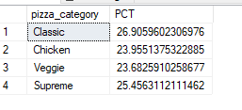
- Percentage of Sales by Pizza Size
SELECT pizza_size, SUM(total_price) AS Total_Sales, CAST(SUM(total_price) * 100/
(SELECT SUM(total_price) FROM pizza_sales) AS DECIMAL (10,2)) AS PCT
FROM pizza_sales
GROUP BY pizza_size
ORDER BY PCT DESC

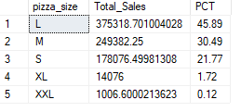
- Total Price sold by Pizza Category
- Top 5 best seller by Revenue, Total Quantity, and Total Order
SELECT TOP 5 pizza_name, SUM(total_price) AS Total_Revenue
FROM pizza_sales
GROUP BY pizza_name
ORDER BY Total_Revenue DESC
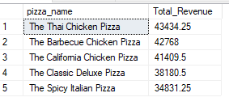
- Bottom 5 Top Sellers by Revenue
SELECT TOP 5 pizza_name, SUM(total_price) AS Total_Revenue
FROM pizza_sales
GROUP BY pizza_name
ORDER BY Total_Revenue ASC
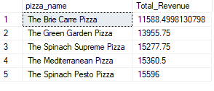
- Top 5 best seller by Total Quantity
SELECT TOP 5 pizza_name, SUM(quantity) AS Total_Quantity
FROM pizza_sales
GROUP BY pizza_name
ORDER BY Total_Quantity DESC
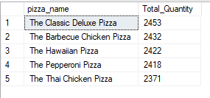
- Bottom 5 Sellers by Quantity
SELECT TOP 5 pizza_name, SUM(quantity) AS Total_Quantity
FROM pizza_sales
GROUP BY pizza_name
ORDER BY Total_Quantity ASC
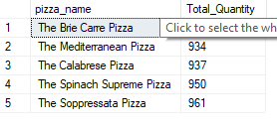
- Top 5 Total Orders
SELECT TOP 5 pizza_name, COUNT(DISTINCT order_id) AS Total_Orders
FROM pizza_sales
GROUP BY pizza_name
ORDER BY Total_Orders DESC
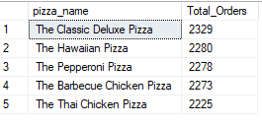
- Bottom 5 Sellers by Total Orders
SELECT TOP 5 pizza_name, COUNT(DISTINCT order_id) AS Total_Orders
FROM pizza_sales
GROUP BY pizza_name
ORDER BY Total_Orders ASC

